Deerlake Supply Lists

2023-2024

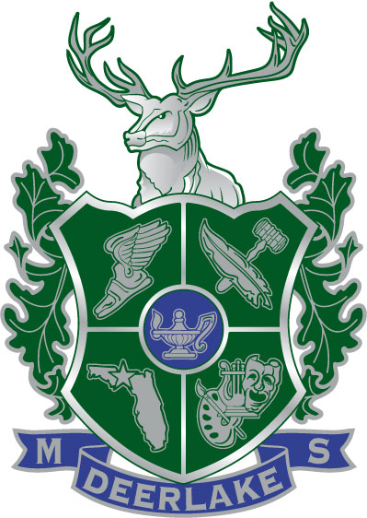**6th Grade Supplies:**

1 – 2” Binder in any color

3 sets of 5 tab tabbed dividers

Colored pencils – 12 count

2 Black Dry erase markers

Highlighters (multiple colors preferred)

2 Each Ink Pens – blue, black & red

2 Packages (1 Dozen) #2 Pencils

2 Packages 3 x 5 Index Cards

Notebook paper

8 Washable Glue sticks (Math and Science)

1 Pencil & Crayon Sharpener

2 Notebook Composition Notebooks (Science and Language Arts)

1 Graphing Composition Notebook (Math)

Headphones/Earbuds - compatible with Chromebook

Planner(we will have DMS planners for sale during orientation and the 1st week of school)

**7th Grade Supplies:**

Notebook paper

#2 Pencils

Tabbed dividers (4 sets)

Blue or black pens

Red pens

Highlighters

Colored pencils

Index cards (several packs)

Graph paper

4 Composition books

TI-30Xa calculator

Binders/notebooks will be necessary, but students may want to wait and decide on the type and quantity that best meets their needs once classes have begun.

**8th Grade Supplies:**

One inch 3-ring binder

Colored pencils

Protractor (Geometry)

Sets of tab dividers

Highlighters

Compass (Geometry)

Wide ruled paper

No. 2 pencils

Composition Notebook (Biology)

Graph paper

Spiral notebook (100 page)

Notecards

Blue, black, red pens

Scientific calculator (TI-30XA)

**Special Notes:**

* **Individual teachers and elective classes may require additional supplies.**
* **Wired Headphones/Earbuds for all grades**
* **Optional- Wireless mouse if preferred.**